**1 Create database – restaurant, create collection – rescollection. Insert the documents into collections.**

from pymongo import MongoClient

import json

import pandas as pd

import numpy as np

#import json

if __name__ == "__main__":

client = MongoClient("mongodb://localhost:27017")

db = client['restaurant']

collection = db['rescollection']

with open('restaurants-dataset.json',"r",encoding="utf-8") as file:

record = file.read()

record = record.replace('\n','')

record = record.replace('}{','},{')

record = "["+record+"]"

file_data = json.loads(record)

if isinstance(file_data,list):

collection.insert_many(file_data)

else:

collection.insert_one(file_data)

**2 Display all the documents in the collection restaurants.**

db.rescollection.find().pretty()

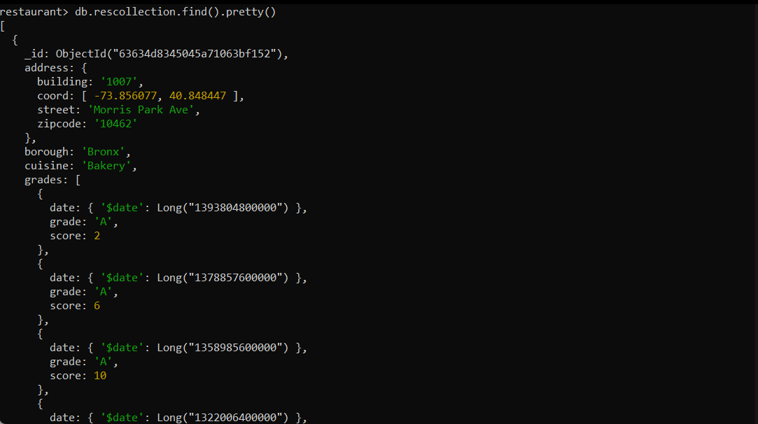

**3 Display the fields restaurant_id, name, borough, and zip code, but exclude the field _id for all the documents in the collection restaurant.**

db.rescollection.find({},{restaurant_id : 1,name : 1,borough : 1,'address.zipcode' : 1,_id : 0})

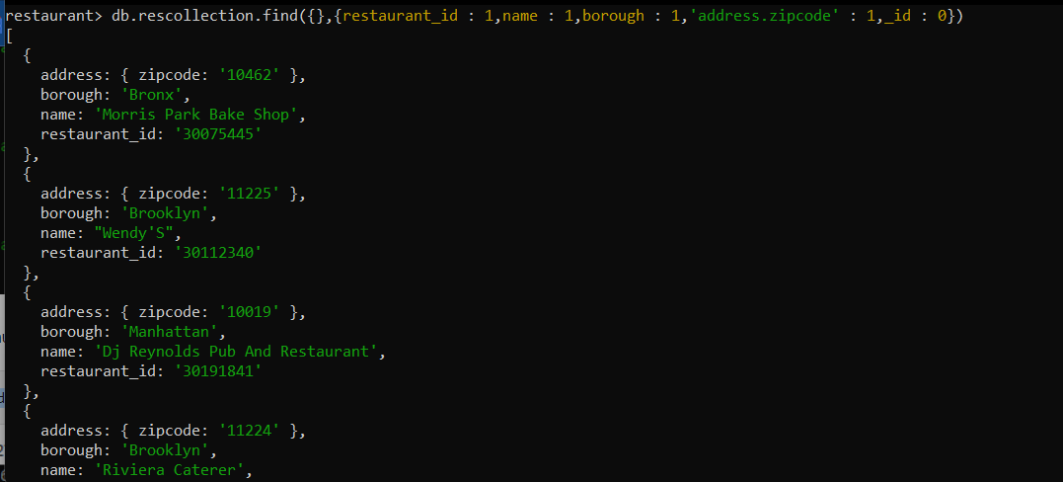

**4 Find the restaurants who achieved a score more than 90.**

db.rescollection.find({'grades.score' : {$gt : 90}},{name : 1,_id:0})

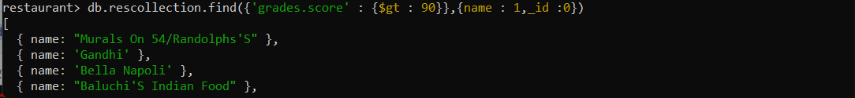

**5 Show the restaurants that achieved a score, more than 80 but less than 100.**

db.rescollection.find({'grades.score' : {$gt : 80,$lt : 100}},{name : 1}

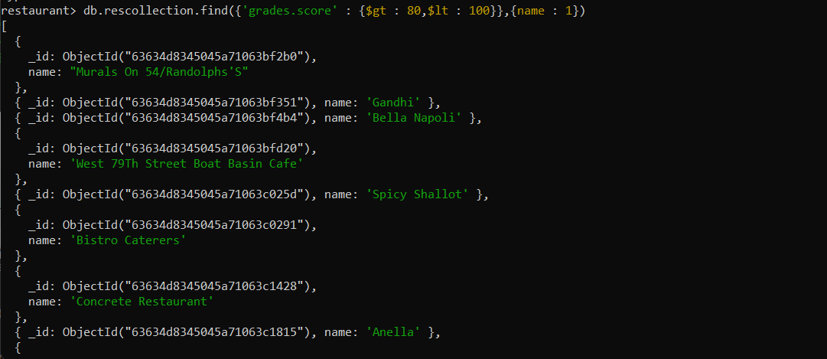

**6 Write Query to show the restaurants that do not prepare any cuisine of american & their grade score > 70**.

db.rescollection.find({$and:[{"cuisine" : {$ne :"American "}},{"grades.score" : {$gt : 70}}]})

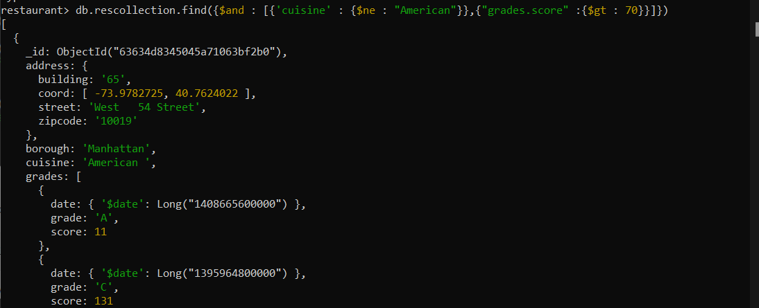

**7 Write a MongoDB query to arrange the name of the cuisine in an ascending order and for that same borough arranged in descending order.**

db.rescollection.find().sort({cuisine : 1,borough : -1})

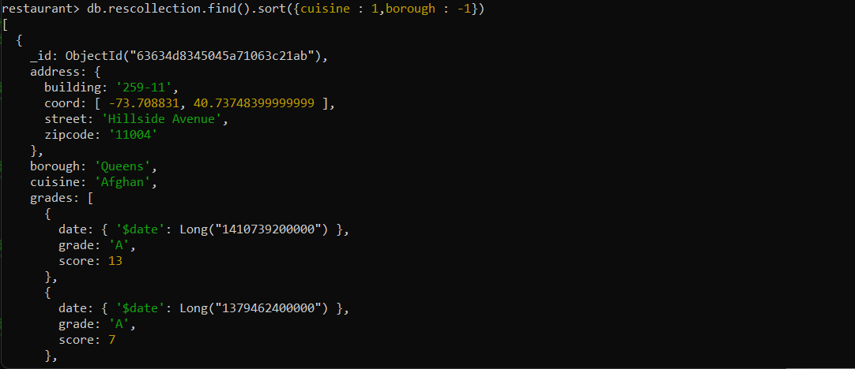

**8 Write a MongoDB query to arrange the name of the cuisine in descending order.**

db.rescollection.find().sort({cuisine:-1})

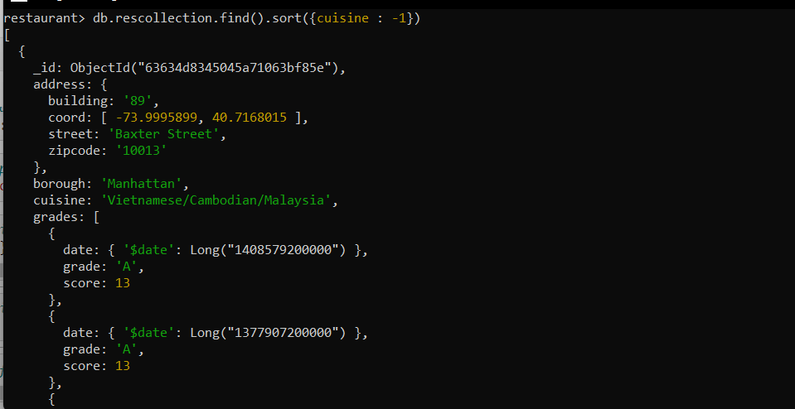

**9 Show the restaurant Id, name, borough and cuisines for those restaurants which prepared dish except 'American' and 'Chinese' or restaurant's name begins with letter 'Bil'.**

db.rescollection.find({$or:[{name: /^Bil/},{$and: [{cuisine: {$ne :"American "}},{cuisine : {$ne :"Chinese"}}]}]},{restaurant_id : 1,name:1,borough:1,cuisine:1})

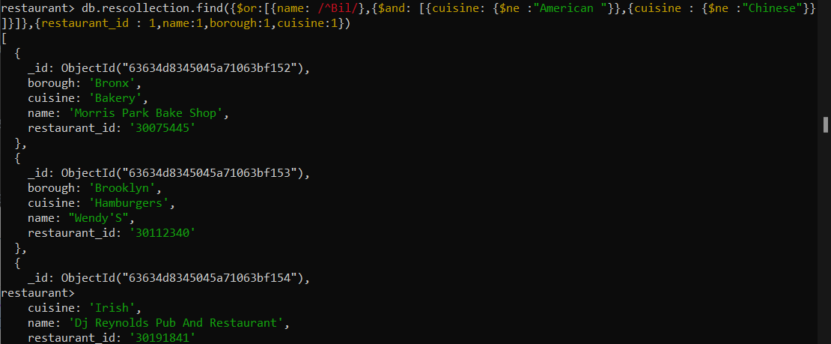

**10 Show the restaurant Id, name, borough and cuisines and score for restaurant's name begins with letter 'Bil'.**

db.rescollection.find({"name" : { $regex : /^Bil.*/}}, {restaurant_id : 1, name : 1,borough: 1,'grades.score' :1, cuisine : 1})

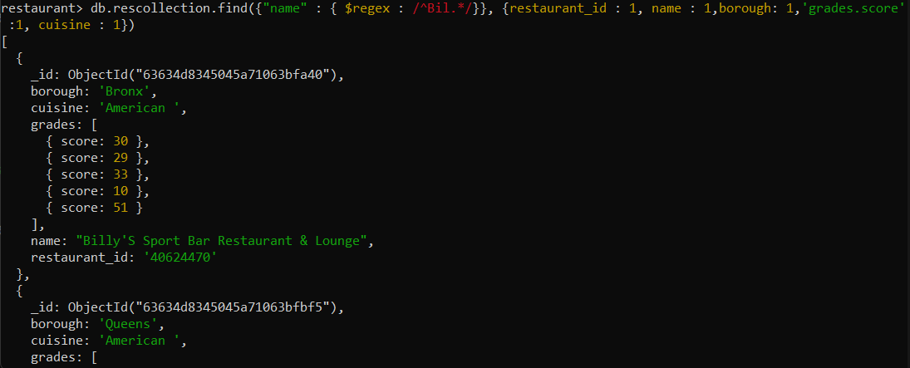

**11 Show the restaurant Id, name, borough and cuisines and score for restaurant serving “Indian” as cuisines.**

db.rescollection.find({cuisine:'Indian'},{restaurant_id:1,name:1,borough:1,cuisine:1,_id:0,'grades.score':1})

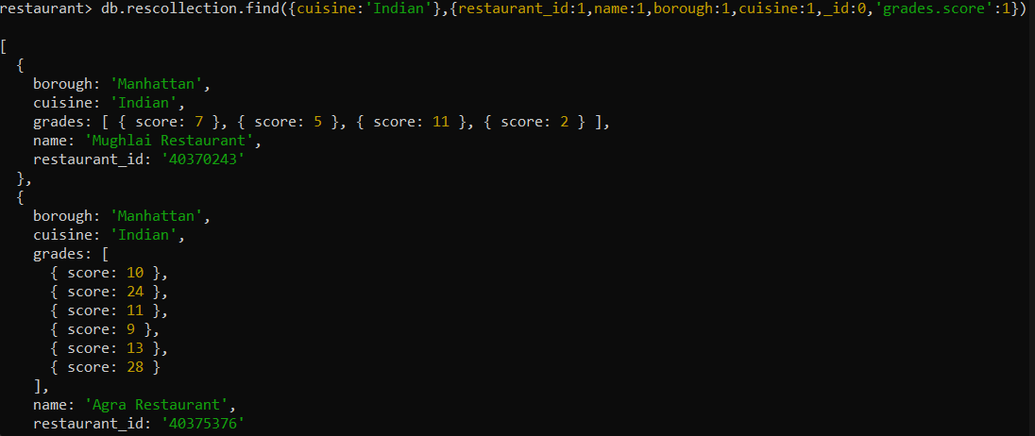

**12 Write a MongoDB query to find the restaurant Id, name, borough, cuisines, and score for those restaurants which contain 'bi' as last three letters for its name**

db.rescollection.find({"name" : { $regex : /.*bi$/}}, {restaurant_id : 1, name : 1,borough: 1,'grades.score' :1, cuisine : 1})

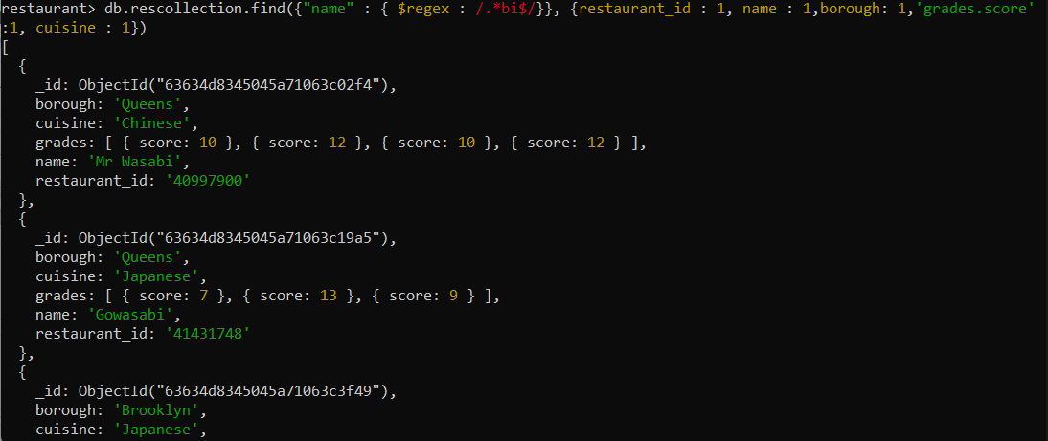

**13 Write a MongoDB query to find the restaurant Id, name, borough, cuisines, and score for those restaurants which contain 'il' as last three letters for its name.**

db.rescollection.find({"name" : { $regex : /.*il$/}}, {restaurant_id : 1, name : 1,borough: 1,'grades.score' :1, cuisine : 1})

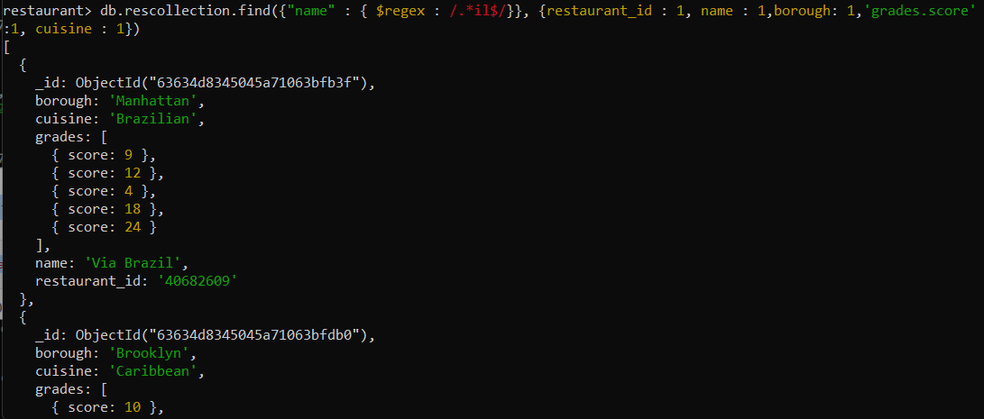

**14 Write a query to show all the restaurant Id, name, borough, cuisines, and score for those restaurants which contain 'il' anywhere in its name.**

db.rescollection.find({"name" : { $regex : /.*il.*/}}, {restaurant_id : 1, name : 1,borough: 1,'grades.score' :1, cuisine : 1})

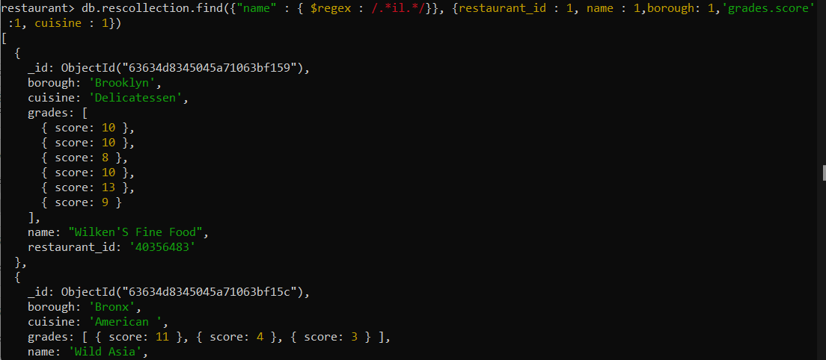

**15 Write a MongoDB query which will select the restaurant Id, name and grades for those restaurants which returns 0 as a remainder after dividing the score by 7.**

db.rescollection.find({"grades.score":{$mod : [7,0]}},{restaurant_id: 1,name:1,grades:1,_id:0})

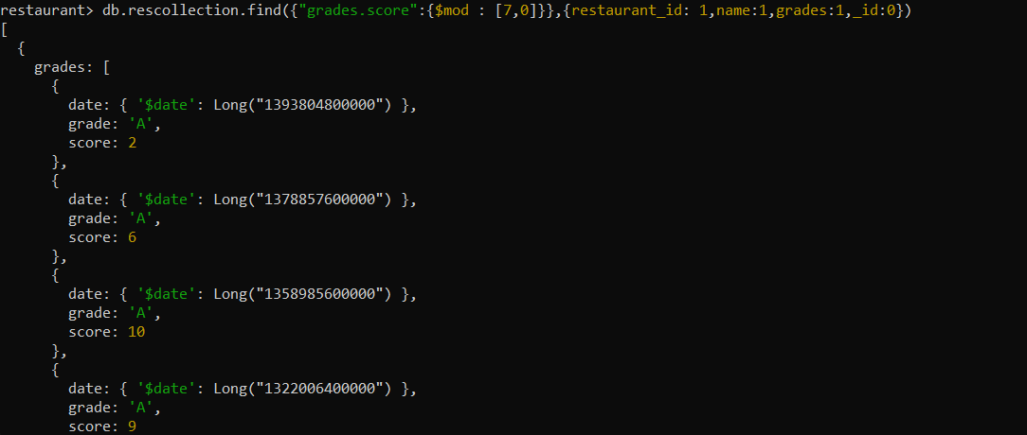

**16 Show document/record counts that has street and not street in addresses.**

db.rescollection.find({"address.street":{ $exists : true }})

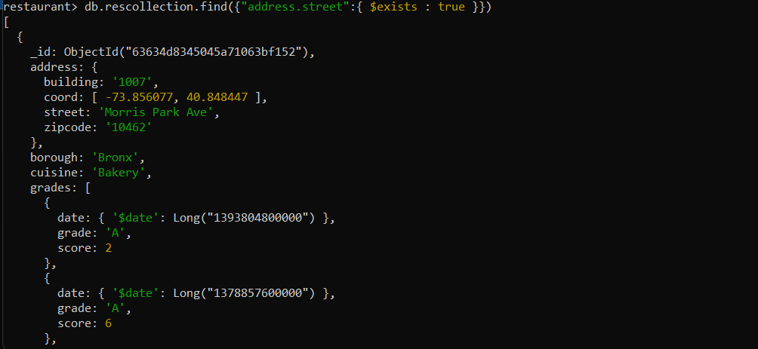

**17 Write a MongoDB query to find the restaurants which do not prepare any cuisine of 'American' and achieved a score more than 70 and located in the longitude less than -65.754168**

db.rescollection.find({$and:[{cuisine:{$ne:'American'}},{"grades.score":{'$gt':70}},{"address.coord" :

{$lt: -65.754168}}]},{'_id':0,'name':1,'restaurant_id':1,'borough':1,'cuisine':1,'grades.score':1})

